**2nd year 1st semester B.Sc. (Hons.) Final Examination- 2017**

IT 2100: Semester Project & Viva

**Obstacle Avoiding Robot Using**

**Arduino and Ultrasonic Sensor**

**Project Supervisor**

Mr. K M Akkas Ali  
Associate Professor

Institute of Information Technology

Jahangirnagar University

**Prepared By**

|  |  |
| --- | --- |
| **Name** | **ID NO.** |
| Fabliha Noshin Sithi | 1974 |
| Kazi Fatema | 1975 |
| Nusaiba Kalam | 1984 |
| MD. Nuruzzaman Sojib | 2000 |



**Institute of Information Technology**

**Jahangirnagar University**

**Savar, Dhaka-1324, Bangladesh**

**DECLARATION**

This project report is submitted to the Institute of Information Technology, Jahangirnagar University, Savar, Dhaka in partial fulfillment of the requirements for having the B.Sc. (Hons.) degree in IT. This is also needed to certify that the project work is under the 2nd year 1st Semester course of the IIT “IT-2100: Semester Project & Viva”. So, we, here declaring that this project report has not been submitted elsewhere for the requirement of any kind of degree, diploma or publication.

**ACCEPTANCE**

This project report is submitted to the Institute of Information Technology, Jahangirnagar University, Savar, Dhaka in partial fulfillment of the requirements for having the B.Sc. (Hons.) degree in IT.

Mr. K M Akkas Ali  
Associate Professor

Institute of Information Technology (IIT)

Jahangirnagar University

Savar, Dhaka-1342, Bangladesh

**ACKNOWLEDGEMENTS**

First of all we would like to thank the Almighty for giving us the opportunity to complete this work successfully. Our acknowledgment is meant to express our sincere gratitude to all those people who have been associated with this project and have helped us with it and by sharing their experiences and valuable opinions through which we received the required information crucial for our project. We are thankful to our parents for their relentless support. Most importantly we are grateful to our honorable supervisor who took time out to guide us and provide us with all the necessary materials and sufficient knowledge that was the major requirement. Finally, we express our thanks to our honorable teacher K M Akkas Ali for giving us the opportunity to learn the subject in a practical.

i

**ABSTRACTION**

The obstacle detection scheme would be based a Ultrasonic sensor HC SR-04 , one for forward direction , a microcontroller in the Arduino would take input from the sensor and then compare the inputs to decide where the robot should turn. It would then give input to the two h-bridges which would in turn direct the motors to control the movement of the robot. Apart from that we will use a 9v battery to power the microcontroller and motors

**Table of Contents Page**

**Chapter 1 Introduction…………………………………………………… 5-6**

1.1 Motivation

1.2 Objective

**Chapter 2: Hardware & Software Segment………………………………. 6**

2.1 Hardware

2.2 Software

**Chapter 3: System of the Model………………………………………….. 7-12**

3.1 Main Features

3.2 Connections

3.3 Components Description

3.4 Design of Obstacle Avoiding Robot

3.5 Working Procedure

3.6 Applications

**Chapter 4: Result……………………………………………………………. 14**

4.1 Output of the Implemented code Using Arduino

**Chapter 5: Conclusion and Future work………………………………….. 15**

**References……………………………………………………………………. 15**

**Chapter 1**

**Introduction**

**1.1 Motivation:**

The project “Obstacle Avoiding Robot using Arduino and Ultrasonic Sensor”, avoids obstacle in its path and immediately changes the path. The project uses Arduino as the controlling element. It uses an Ultrasonic sensor. When the obstacle comes in path of robot the sensor send sound to the obstacle and it reflected from the obstacle then sensor gives zero voltage to µc. This zero voltage is detected then µc decides to avoid the obstacle by taking left or right turn. If the sensor gives +5v to µc that means there is no obstacle present in its path so it goes straight until any obstacle is detected. The two IR transmitter circuits are fitted on front side of robot. The connections can be given from main circuit to sensors using simple twisted pair cables. Two motors namely right motor and left motor are connected to driver IC (L298D). L298D is interface with µc. Micro-controller sends logic 0 & logic 1 as per the programming to driver IC which moves motors forward or reverse direction. Nowadays with the advancement of technology particularly in the field of micro-controllers, all the activities in our day-to-day living have become part of information technology and we find controllers in each and every application. Thus, the trend is directing towards micro-controller based project works. A micro-controller contains a CPU, clock circuitry, ROM, Ram and I/O circuitry on a single integrated circuit package

**1.2 Objective:**

The principal objectives of our project are:

* The robot would have the capacity to detect obstacles in its path based on a predetermined threshold distance.
* After obstacle detection, the robot would change its course to a relatively open path by making autonomous decision.
* It would require no external control during its operation.
* It can measure the distance between itself and the surrounding objects in real-time.
* It would be able to operate effectively in unknown environment.

Automotive and other weather con

**Chapter 2**

**Hardware and Software Segment**

There are a couple of things we need for this project in addition,

**2.1. Hardware:**

1. Chassis OR any toy car.
2. Ultrasonic sensor HC SR-04.
3. 2 DC motors.
4. 9V/12V 1A battery.
5. Motor driver module L298.
6. Jumpers.
7. Single stranded wires.

**2.2. Software:**

1. Arduino UNO

**Chapter 3**

**Design of Model**

3.1. Main features:

The main parts of this projects are Ultrasonic Senor, Arduino Uno( Microcontroller) and Motor Driver

**Micro-Controller**

**Motor Driver**

**Ultrasonic Sensor**

**Left Motor**

Fig: 3.1: Block diagram of System

**3.2. Connections:**

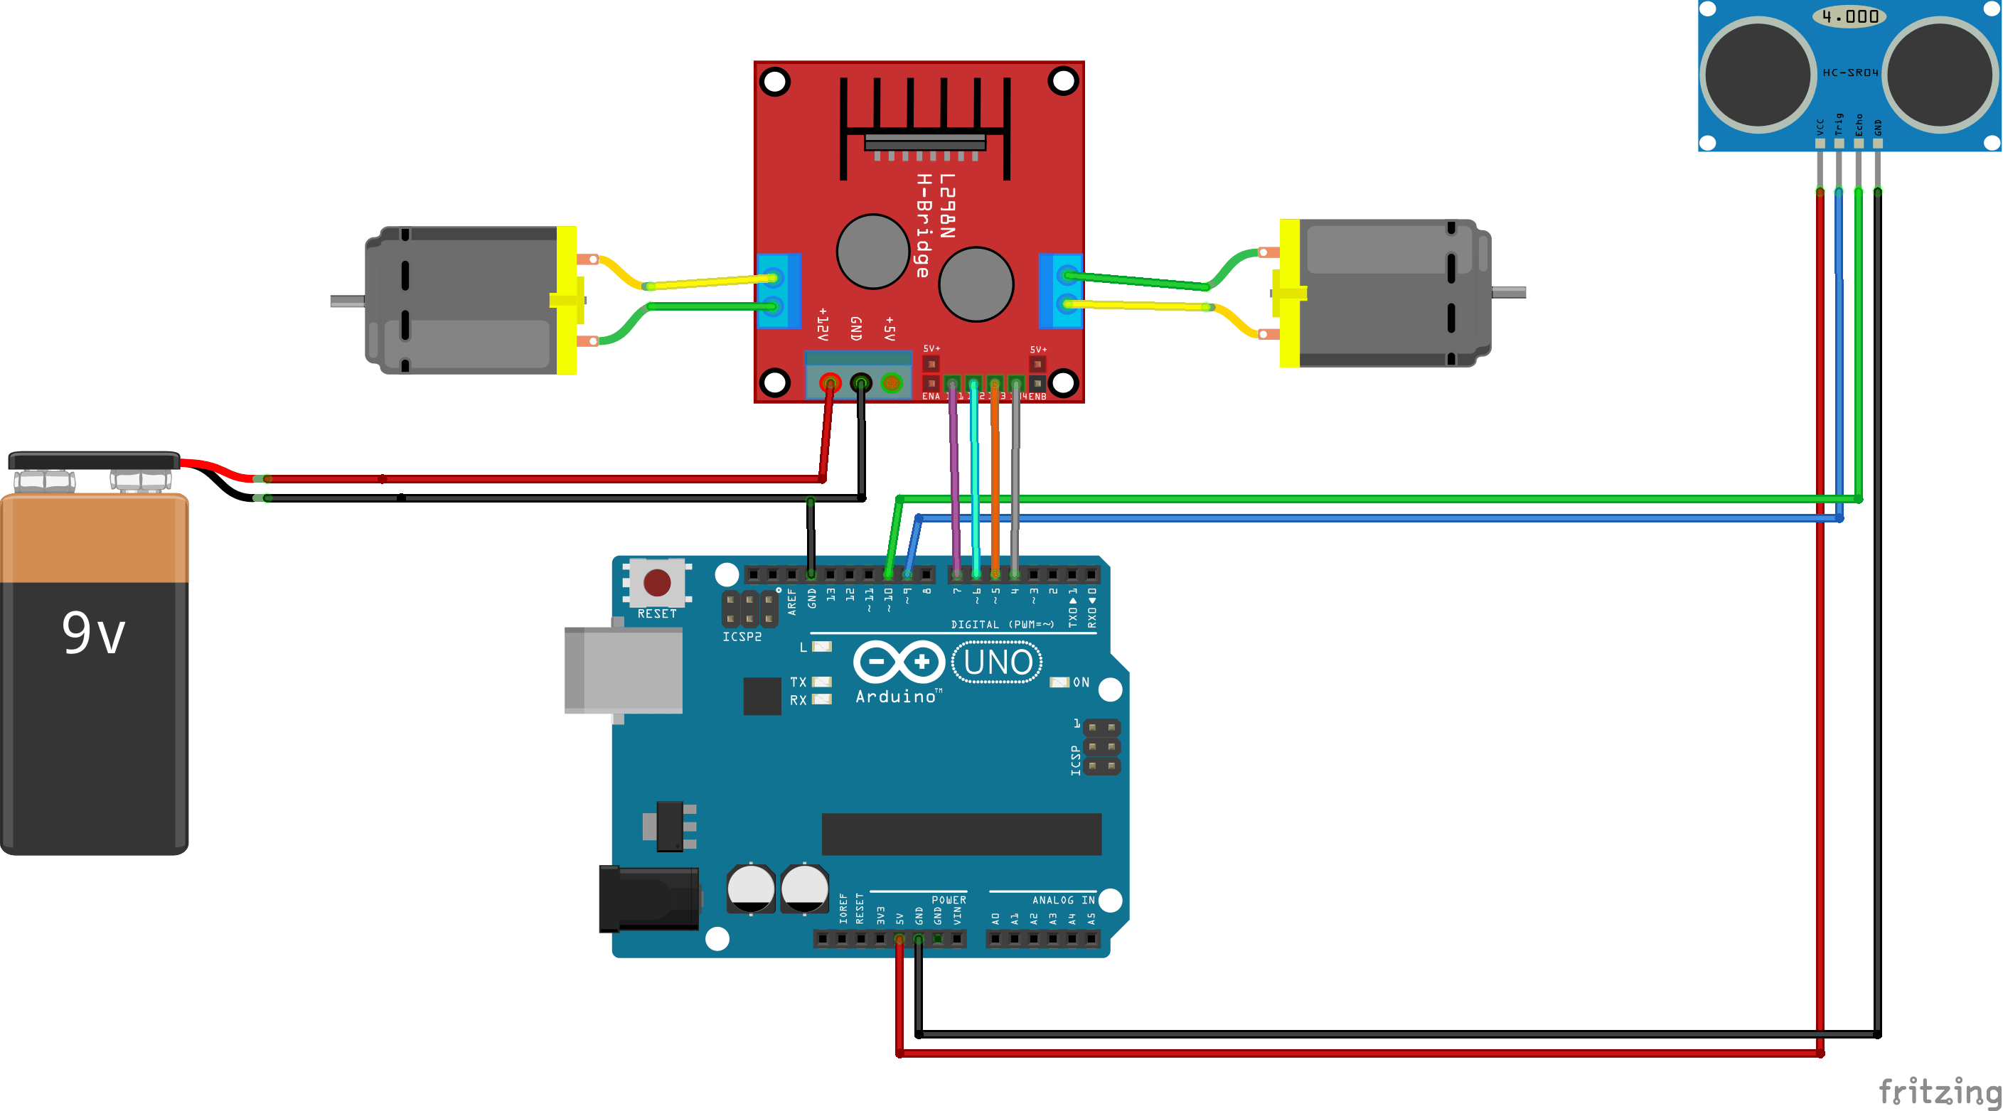

Diagram 3.2: Connections for obstacle avoiding robot

Connections of Ultrasonic sensor –

1. VCC – VCC terminal of Arduino.
2. GND – GND terminal of Arduino.
3. Trigpin – digital pin 3 on Arduino.
4. Echo pin – digital pin 4 on Arduino.

Connections of L298N –

1. +12V – Positive terminal of the battery.
2. GND – Negative terminal of battery.
3. Input terminal 1 – Pin 5
4. Input terminal 2 – Pin 6
5. Input terminal 3 – Pin 7
6. Input terminal 4 – Pin 8
7. Output terminal 1 – Positive of first motor.
8. Output terminal 2 – Negative of first motor.
9. Output terminal 3 – Positive of second motor
10. Output terminal 4 – Negative of second motor

**3.3. Components Description**

#### . **Arduino Uno**

Arduino Uno is an ATmega 328p Microcontroller based prototyping board. It is an open source electronic prototyping platform that can be used with various sensors and actuators. Arduino Uno has 14 digital I/O pins out of which 6 pins are used in this project.

**HC – SR04**

It is an Ultrasonic Range Finder Sensor. It is a non-contact based distance measurement system and can measure distance of 2cm to 4m.

**L293D**

It is a motor driver which can provide bi-directional drive current for two motors.

**Servo Motor**

The Tower Pro SG90 is a simple Servo Motor which can rotate 90 degrees in each direction (approximately 180 degrees in total).

**3.4. Design of Obstacle Avoiding Robot:**

Arduino is the main processing unit of the robot. Out of the 14 available digital I/O pins, 7 pins are used in this project design.

The ultrasonic sensor has 4 pins: Vcc, Trig, Echo and Gnd. Vcc and Gnd are connected to the +9v and GND pins of the Arduino. Trig (Trigger) is connected to the 9th pin and Echo is connected to 8th pin of the Arduino UNO respectively.

A Servo Motor is used to rotate the Ultrasonic Sensor to scan for obstacles. It has three pins namely Control, VCC and GND. The Servo Control Pin is connected to pin 11 of Arduino while the VCC and GND are connected to +9V and GND.

L293D is a 16 pin IC. Pins 1 and 9 are the enable pins. These pins are connected to +9V.  Pins 2 and 7 are control inputs from microcontroller for first motor. They are connected to pins 6 and 7 of Arduino respectively.

Similarly, pins 10 and 15 are control inputs from microcontroller for second motor. They are connected to pins 5 and 4 of Arduino. Pins 4, 5, 12 and 13 of L293D are ground pins and are connected to Gnd.

First motor (consider this as the motor for left wheel) is connected across the pins 3 and 6 of L293D. The second motor, which acts as the right wheel motor, is connected to 11 and 14 pins of L293D.

The 16th pin of L293D is Vcc1. This is connected to +9V. The 8th pins is Vcc2. This is the motor supply voltage. This can be connected anywhere between 4.7V and 36V. In this project, pin 8 if L293D is connected to +9V supply.

**3.5. Working Procedure:**

Before going to working of the project, it is important to understand how the ultrasonic sensor works. The basic principle behind the working of ultrasonic sensor is as follows:

Using an external trigger signal, the Trig pin on ultrasonic sensor is made logic high for at least 10µs. A sonic burst from the transmitter module is sent. This consists of 8 pulses of 40KHz.

The signals return back after hitting a surface and the receiver detects this signal. The Echo pin is high from the time of sending the signal and receiving it. This time can be converted to distance using appropriate calculations.

The aim of this project is to implement an obstacle avoiding robot using ultrasonic sensor and Arduino. All the connections are made as per the circuit diagram. The working of the project is explained below.

When the robot is powered on, both the motors of the robot will run normally and the robot moves forward. During this time, the ultrasonic sensor continuously calculate the distance between the robot and the reflective surface.

This information is processed by the Arduino. If the distance between the robot and the obstacle is less than 25cm, the Robot stops and scans in left and right directions for new distance using Servo Motor and Ultrasonic Sensor. If the distance towards the left side is more than that of the right side, the robot will prepare for a left turn. But first, it backs up a little bit and then activates the Left Wheel Motor in reversed in direction.

Similarly, if the right distance is more than that of the left distance, the Robot prepares right rotation.  This process continues forever and the robot keeps on moving without hitting any obstacles.

**3.6. Applications:**

1. This logic has been specially designed for vacuum cleaner. By using heavy rating motors, strong mechanical structure and using highly sensitive obstacle sensors, it efficiently work as vacuum cleaner.
2. Just by making small changes in software this system can be used for avoiding concealed paths. This robot can effectively sense the obstacles and find out correct path.
3. With proper programming we can use it as a weight lifter.
4. In Mines.

**Chapter 4**  
 **RESULT**

**4.1:**

**Chapter 5**

**Conclusion and Future work**

This project developed an obstacle avoiding robot to detect and avoid obstacles in its path. The robot is built on the Arduino platform for data processing and its software counterpart helped to communicate with the robot to send parameters for guiding movement. For obstacle detection, three ultrasonic distance sensors were used that provided a wider field of detection. The robot is fully autonomous and after the initial loading of the code, it requires no user intervention during its operation. When placed in unknown environment with obstacles, it moved while avoiding all obstacles with considerable accuracy.

The work done in this project can act as a base for further improvements to increase accuracy and adaptability of obstacle detection in diverse environments. In future, the authors of this project intend to test the feasibility of integrating different types of sensors to complement each other’s disadvantages. For instance, imaging sensor can be beneficial when ultrasonic sensor may not correctly identify obstacles in environment subjected to ambient noise and varying temperature or air pressure. The accuracy of determining the distance to the obstacles can be increased by the inclusion of an electronic barometer for automatic adjustment of the speed of sound in air. Also the addition of a Bluetooth device can offer the flexibility of remotely changing control parameters in the code.

**References**

* [www.youtube.com](http://www.youtube.com)
* [www.google.com](http://www.google.com)
* <http://mechstuff.com/how-to-make-obstacle-avoiding-robot-using-arduino-ultrasonic-sensor/>

<http://www.electronicshub.org/obstacle-avoiding-robot-arduino/>